**Digital Nurture 4.0 Deep Skilling - Java FSE**  
**WEEK –6 Hands-on Exercises**  
**Module 10 - React**

**1. ReactJS-HOL**

**Solution:**

**Code:**

**To create a React Application with the name of “myfirstreact”, type the following command:**  
npx create-react-app myfirstreact

**Once the App is created, navigate into the folder of myfirstreact by typing the following command:**

cd myfirstapp

**App.js**

import React from 'react';

function App() {

return (

<div>

<h1>welcome to the first session of React</h1>

</div>

);

}

export default App;

**Output:**

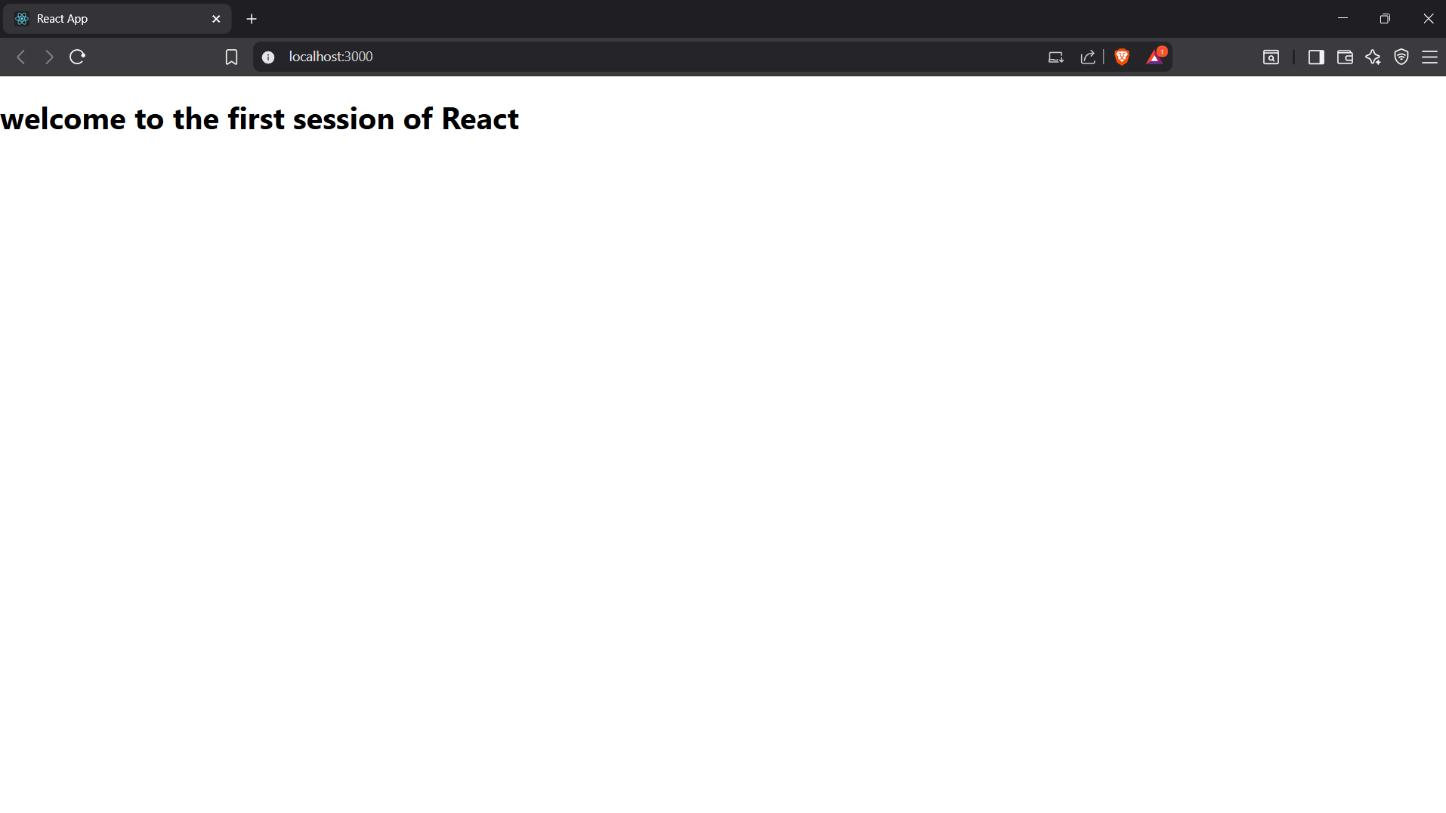

**2. ReactJS-HOL**

**Solution:**

**Code:**

**Home.js**  
import React from 'react';

function About() {

return (

<div>

<h2>Welcome to the About page of the Student Management Portal</h2>

</div>

);

}

export default About;

**Contact.js**

import React from 'react';

function Contact() {

return (

<div>

<h2>Welcome to the Contact page of the Student Management Portal</h2>

</div>

);

}

export default Contact;

**About.js**

import React from 'react';

function About() {

return (

<div>

<h2>Welcome to the About page of the Student Management Portal</h2>

</div>

);

}

export default About;

**App.js**

import React from 'react';

import Home from './Components/Home';

import About from './Components/About';

import Contact from './Components/Contact';

function App() {

return (

<div>

<Home />

<About />

<Contact />

</div>

);

}

export default App;

**Output:**

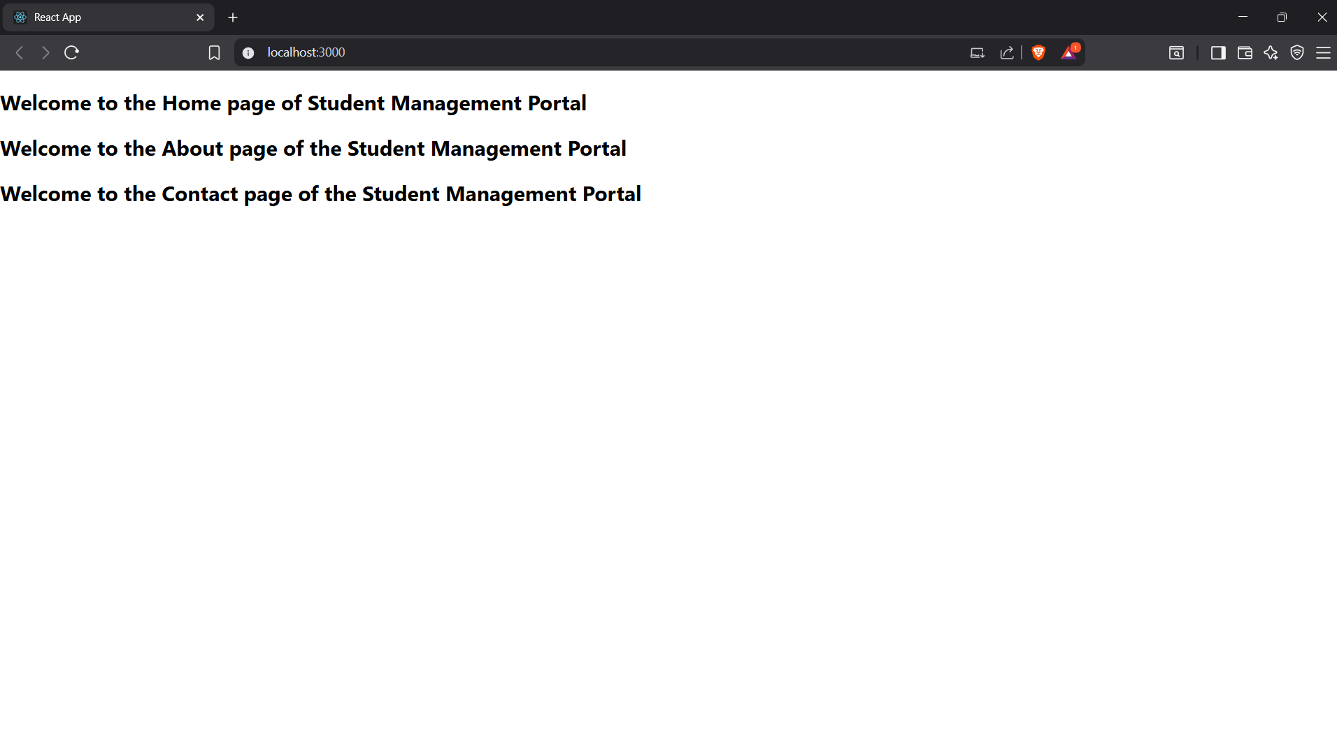

**3. ReactJS-HOL**

**Solution:**

**Code:**

**CalculateScore.js**  
import React, { useState } from 'react';

import '../Stylesheets/mystyle.css';

function CalculateScore() {

const [name, setName] = useState('');

const [school, setSchool] = useState('');

const [total, setTotal] = useState('');

const [goal, setGoal] = useState('');

const [average, setAverage] = useState(null);

const handleSubmit = (e) => {

e.preventDefault();

if (total && goal && !isNaN(total) && !isNaN(goal)) {

setAverage((parseFloat(total) / parseFloat(goal)).toFixed(2));

} else {

setAverage('Invalid input');

}

};

return (

<div className="score-container">

<h2 className="title">Student Score Calculator</h2>

<form onSubmit={handleSubmit} className="score-form">

<label>

Name:

<input type="text" value={name}

onChange={e => setName(e.target.value)}

required

/>

</label>

<label>

School:

<input type="text" value={school}

onChange={e => setSchool(e.target.value)}

required

/>

</label>

<label>

Total Score:

<input type="number" value={total}

onChange={e => setTotal(e.target.value)}

required

/>

</label>

<label>

Goal (Number of Subjects):

<input type="number" value={goal}

onChange={e => setGoal(e.target.value)}

required

/>

</label>

<button type="submit">Calculate Average</button>

</form>

{average !== null &&

<div className="result">

<h3>Result</h3>

<p><strong>Name:</strong> {name}</p>

<p><strong>School:</strong> {school}</p>

<p><strong>Average Score:</strong> {average}</p>

</div>

}

</div>

);

}

export default CalculateScore;

**mystyle.css**

.score-container {

margin: 30px auto;

padding: 30px;

max-width: 400px;

border-radius: 10px;

background: #f8f9fa;

box-shadow: 0 4px 12px rgba(0,0,0,0.10);

font-family: Arial, sans-serif;

}

.title {

text-align: center;

color: #1b5e20;

}

.score-form label {

display: block;

margin: 15px 0 5px;

font-weight: 600;

}

.score-form input {

width: 100%;

padding: 7px;

margin-bottom: 10px;

border: 1px solid #aaa;

border-radius: 4px;

font-size: 1em;

}

.score-form button {

width: 100%;

background: #388e3c;

color: white;

padding: 10px;

border: none;

border-radius: 4px;

font-size: 1em;

cursor: pointer;

margin-top: 10px;

transition: background 0.2s;

}

.score-form button:hover {

background: #2e7031;

}

.result {

background: #e0f2f1;

border-radius: 6px;

padding: 15px;

margin-top: 20px;

text-align: center;

}

.result h3 {

color: #00695c;

margin-bottom: 10px;

}

**App.js**

import React from 'react';

import CalculateScore from './Components/CalculateScore';

function App() {

return (

<div>

<CalculateScore />

</div>

);

}

export default App;

**Output:**

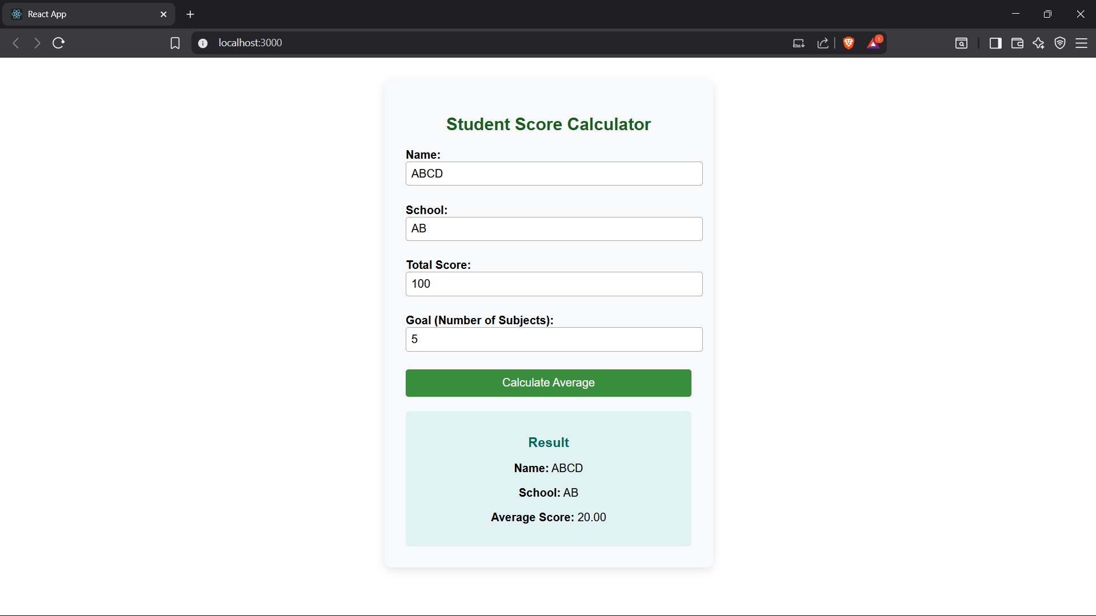

**4. ReactJS-HOL**

**Solution:**

**Code:**

**Post.js**  
import React from 'react';

function Post({ title, body }) {

return (

<div style={{marginBottom:'1.5rem',borderBottom:'1px solid

#aaa',paddingBottom:'1rem'}}>

<h3>{title}</h3>

<p>{body}</p>

</div>

);

}

export default Post;

**Posts.js**

import React, { Component } from "react";

import Post from "./Post";

class Posts extends Component {

constructor(props) {

super(props);

this.state = {

posts: [],

hasError: false,

errorMsg: ""

};

}

loadPosts = () => {

fetch("https://jsonplaceholder.typicode.com/posts")

.then((res) => {

if (!res.ok) throw new Error("API Error");

return res.json();

})

.then((data) => this.setState({ posts: data.slice(0, 10) }))

.catch((err) => {

this.setState({ hasError: true, errorMsg: err.message });

});

};

componentDidMount() {

this.loadPosts();

}

componentDidCatch(error, info) {

this.setState({ hasError: true, errorMsg: error.toString() });

alert("Error in Posts component: " + error.toString());

}

render() {

if (this.state.hasError)

return <h2 style={{ color: "red" }}>Something went wrong: {this.state.errorMsg}</h2>;

return (

<div>

<h2>Blog Posts</h2>

{this.state.posts.length === 0 && <p>Loading posts...</p>}

{this.state.posts.map((post) => (

<Post key={post.id} title={post.title} body={post.body} />

))}

</div>

);

}

}

export default Posts;

**App.js**

import React from "react";

import Posts from "./Posts";

function App() {

return (

<div style={{ maxWidth: 700, margin: "auto", padding: "2rem" }}>

<Posts />

</div>

);

}

export default App;

**Output:**

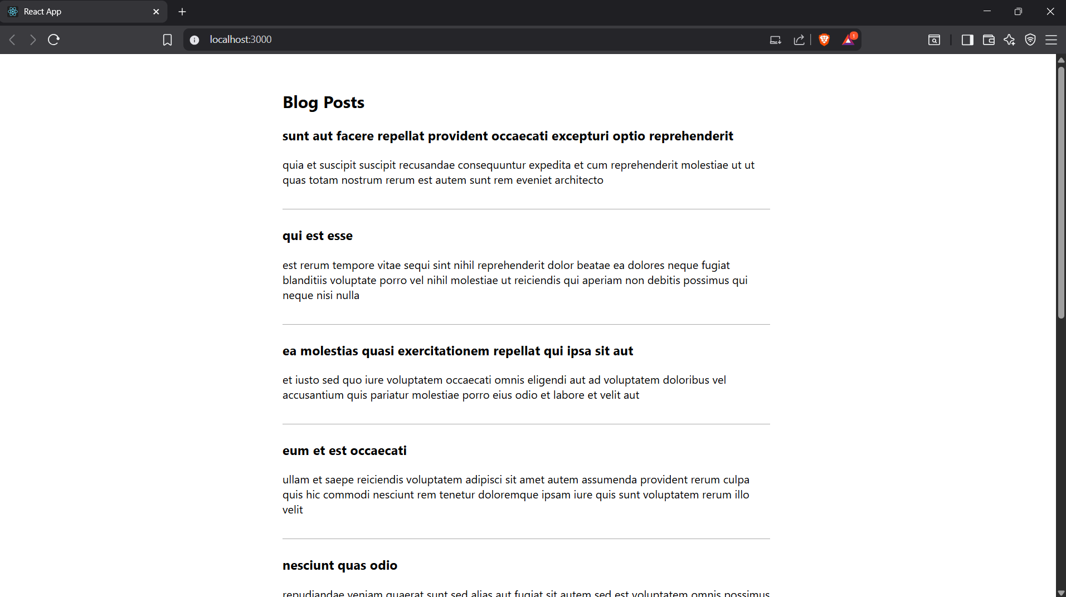

**5. ReactJS-HOL**

**Solution:**

**Code:**

**CohortDetails.module.css**  
.box {

width: 300px;

display: inline-block;

margin: 10px;

padding: 10px 20px;

border: 1px solid black;

border-radius: 10px;

}

dt {

font-weight: 500;

}

**CohortDetails.js**

import React from 'react';

import styles from './CohortDetails.module.css';

function CohortDetails({ cohort }) {

return (

<div className={styles.box}>

<h3 style={{ color: cohort.status === 'ongoing' ? 'green' : 'blue' }}>

{cohort.title}

</h3>

<dl>

<dt>Cohort Name:</dt>

<dd>{cohort.name}</dd>

<dt>Start Date:</dt>

<dd>{cohort.startDate}</dd>

<dt>Status:</dt>

<dd>{cohort.status}</dd>

</dl>

</div>

);

}

export default CohortDetails;

**App.js**

import React from 'react';

import CohortDetails from './CohortDetails';

function App() {

const cohorts = [

{

title: 'Ongoing Cohort 1',

name: 'Cohort Alpha',

startDate: '2025-07-01',

status: 'ongoing',

},

{

title: 'Completed Cohort 2',

name: 'Cohort Beta',

startDate: '2025-01-15',

status: 'completed',

},

];

return (

<div style={{ padding: '20px' }}>

{cohorts.map((cohort, index) => (

<CohortDetails key={index} cohort={cohort} />

))}

</div>

);

}

export default App;

**Output:**

